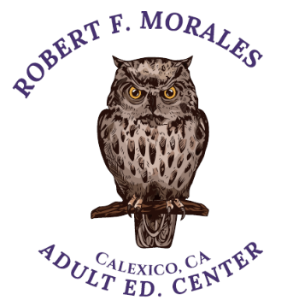 **CALEXICO UNIFIED SCHOOL DISTRICT**

**ROBERT F. MORALES**

**ADULT EDUCATION CENTER**

***CLASS TEACHER DAYS***

**MORNING 8:45 – 11:45 AM**

**ESL BEG AM 030111 MS. MELENDEZ M,W,F**

**ESL BEG AM 030113 MS. MELENDEZ TU,THURS**

**ESL INT HIGH AM 030212 MS. CAMPOS TU,THURS**

**ESL ADV 030313 MS. CAMPOS MO,W,FRI**

**HIGH SCHOOL SUB 022029 MR. ZAMORES MO - FRI**

**NOON 12:15 PM – 3:15 PM**

**ESL INT LOW 030213 MS. CAMPOS M,W,F**

**ESL INT LOW 030214 MS. CAMPOS TU,THURS**

**GED 022028 MR. ZAMORES MO - FRI**

**EVENING 5:00 PM – 8:00 PM**

**ESL BEG 030130 MR. DOMINGUEZ T,W**

**ESL INT 030231 MR. RAZO TU,THURS**

**ESL ADV 0303 MS. MELENDEZ MON,WED**

**GED 090140 MS. SANTOYO TU,WE**

**EL CIVICS 050111 MR. ZAMORES TUE,THU**

**MED ADMIN ASSIST. 050MED MS. PACHECO TUE,THU**

**COMPUTER SCIENCE 040222 MS.PACHECO MON,WED**