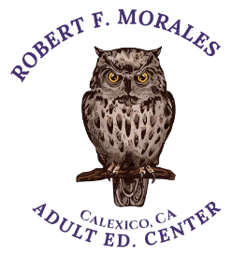CALEXICO UNIFIED SCHOOL DISTRICT

ROBERT F. MORALES ADULT ED CENTER

1391 KLOKE ROAD, CALEXICO, CA 92231

Phone Number (760) 768-3914

[cmartija@cusdk12.org](mailto:cmartija@cusdk12.org)

[msamano@cusdk12.org](mailto:msamano@cusdk12.org)

ENROLLMENT REQUIREMENTS: **PROOF OF RESIDENCY**

2 UTILITY BILLS IN YOUR NAME (Electricity, gas or water ONLY)

1 MORTGAGE BILL OR DEED OF TRUST

1 RENT RECEIPT, RENTAL AGREEMENT (If bills are included, specify, please.)

*If you live with friends, you will need either a Declaration of Residency with another family “Apendice U” (May be used only once and is valid for 90 day)

* Declaration of Residency with immediate family, “Apendice U.1”. Homeowner must accompany interested party at the time of registration to sign the form and provide proof of residency.

1 UNITED STATES PICTURE IDENTIFICATION

CLASS SCHEDULES

Horarios de clases

8:45 A.M. – 11:45 A.M. 12:15 P.M. – 3:15 P.M. 5:00 P.M. – 8:00 P.M

REQUISITOS PARA INSCRIPCION: **COMPROBANTE DE RESIDENCIA**

2 RECIBOS DE UTILIDADES (ELECTRICIDAD, AGUA, GAS)

1 COPIA DEL ULTIMO ESTADO DE CUENTA DE LA HIPOTECA O TITULO DE PROPIEDAD

1 CONTRATO Y RECIBO DEL ULTIMO MES DE RENTA (Incluyendo 2 recibos de agua, electricidad o gas)

*Si vive con parientes lejanos o amigos, el dueño de la casa deberá acompañar al interesado para firmar la forma “*Apendice U*” (Válida unicamente por 90 días, una sola vez)

*Si vive con familia inmediata necesitará una Declaración de Residencia con familia inmediata “*Apendice U.1*”

1 IDENTIFICACION OFICIAL CON FOTOGRAFIA